**Assignment-2**

1. **Image Classification Problem:**
   1. **Dataset**

* The CIFAR-10 dataset, containing 60,000 32x32 colour images across 10 classes, was used.
  1. **Data Preparation**
* Data was split into 80% training and 20% validation sets, stratified by class.
* Data augmentation techniques employed:
  + - * + Random horizontal flips
        + Random cropping
        + Random Rotation (By 15 degrees)
        + Normalization (brightness=0.2, contrast=0.2, saturation=0.2, hue=0.1)
        + Colour Jitter
      * Augmentation was demonstrated to improve model performance.
  1. **Models**
* Pretrained ResNet-50: Trained on the CIFAR-10 dataset.
* Pretrained EfficientNet-b0: Trained on the CIFAR-10 dataset.

**1.4 Loss Function**

* Negative Log-Likelihood (NLL) loss.

**1.5 Training**

* Optimizer: Stochastic Gradient Descent (SGD)
* Batch Size: 256
* Learning Rate: 0.001
* Learning Rate Scheduler: Employed (step size=3, gamma=0.1).
* Epochs: 5 (Note: More epochs may be needed based on convergence, couldn’t go for it due to resource constraint i.e. availability of GPUs).

**1.6 Results**

* Test Accuracy:
* ResNet-50: 77.30%
* EfficientNet-b0: 56.61%
* Model Comparison: ResNet-50 outperformed EfficientNet-b0 model in image classification task on CIFAR10 dataset.
* Also I saved the final checkpoints of both the models in .pth format
* Also, I have included code on how to leverage those saved models to predict the label of the given image.

**1.7 Challenges Faced**

* I had a GPU limit which made me not to go for higher extents.
* Choosing proper augmentation methods, values of batch size and learning rate.

**Training history of the models:**

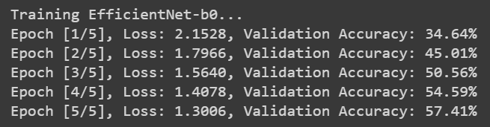



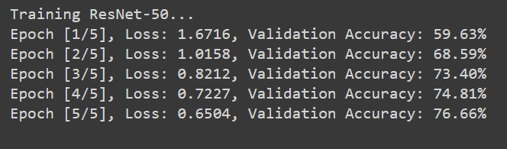



**Resnet-50 Architecture:**

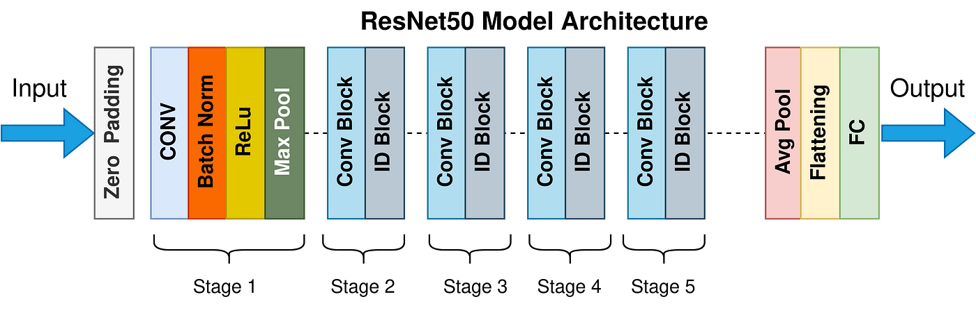

**EfficientNet-b0 Architecture:**

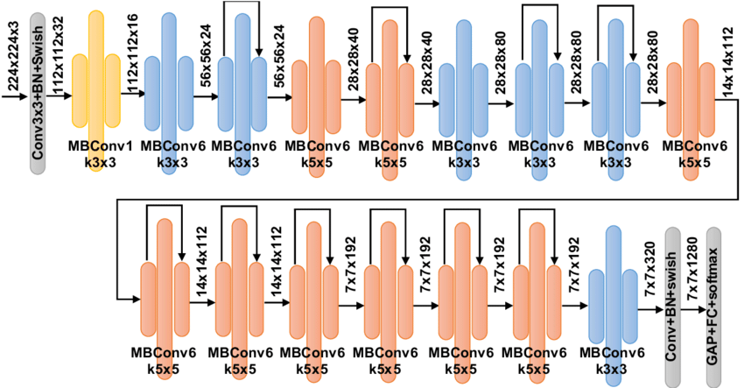

1. **Image Segmentation Problem:**
   1. **Dataset**

* Cityscapes dataset (fine annotations, which contain 5000 images).
* 3500 images used for training and 1500 images used for testing.
  1. **Model**
* U-Net architecture (I have define Encoder, Decoder and Bottle Neck)
  1. **Loss Function**
* Combined NLL loss and DICE loss.
  1. **Results**
* Test DICE Score: 0.67
* Mean Average Precision: 0.55

